10.22: a) The acceleration down the slope is 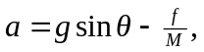the torque about the center of the shell is
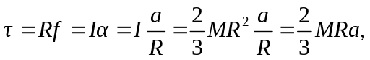
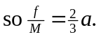 Solving these relations for and simultaneously gives 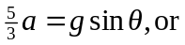
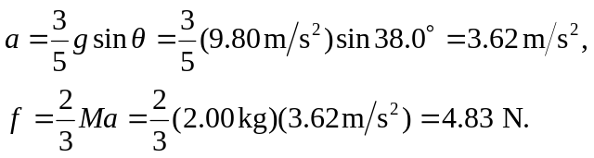
The normal force is Mg cos , and since 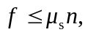
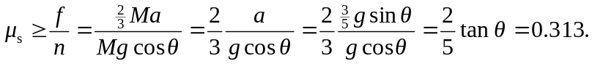

b) 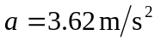since it does not depend on the mass. The frictional force, however,
is twice as large, 9.65 N, since it does depend on the mass. The minimum value of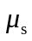 also
does not change.

